ultramirinc.champs_mood.models

Class MyLocation

java.lang.Object ultramirinc.champs_mood.models.MyLocation



public class MyLocation extends java.lang.Object

Created by Etienne Berube on 2017­05­10. This class acts as an alternative to the LatLng object provided by Google. However, the LatLng object cannot be stored in the database. Thus, we created this object.



*Field Summary*

Fields

Modifier and Type Field and

Description

private double lat

A latitude

private double lng

A longitude

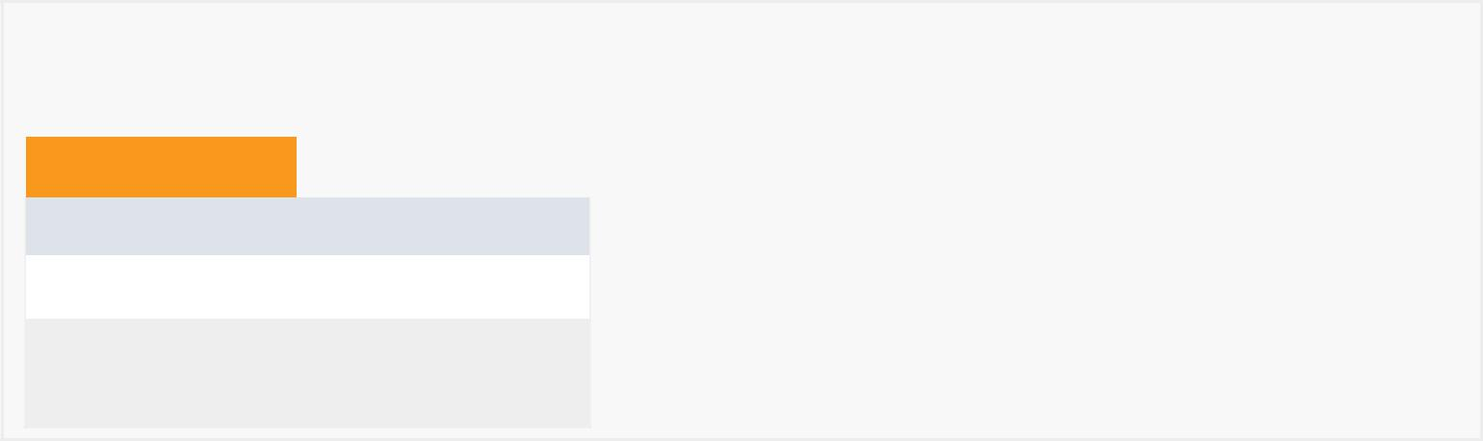

*Constructor Summary*

Constructors

Constructor and Description

MyLocation()

MyLocation(double lat, double lng)



*Method Summary*

All Methods

[Instance Methods](javascript:show(2);)

[Concrete Methods](javascript:show(8);)

Modifier and Type Method and

Description

double getLat()

|  |  |
| --- | --- |
|  | Getter for the |
|  | latitude. |
|  |  |
| double | getLng() |
|  | Getter for the |
|  | longitude. |
| void | setLat(double lat) |
|  | Setter for the |
|  | latitude. |
|  |  |
| void | setLng(double lng) |
|  | Setter for the |
|  | longitude. |
|  |  |

Methods inherited from class java.lang.Object

clone, equals, finalize, getClass, hashCode, notify, notifyAll, toString, wait, wait, wait



*Field Detail*

lat

private double lat

A latitude

lng

private double lng

A longitude



*Constructor Detail*

MyLocation

public MyLocation()

MyLocation

public MyLocation(double lat, double lng)

*Method Detail*

getLat

public double getLat()

Getter for the latitude.

setLat

public void setLat(double lat)

Setter for the latitude.

getLng

public double getLng()

Getter for the longitude.

setLng

public void setLng(double lng)

Setter for the longitude.